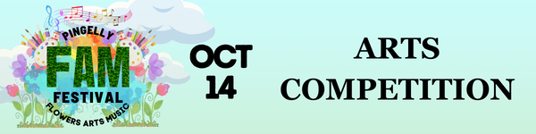

By entering the 2023 Pingelly FAM Festival Art Competition you agree to accept and comply with the Conditions of Entry outlined below.

Conditions of Entry
- Closing date for Entry Forms: Entry forms are due by Monday 9th October. Email to ellen.cook@pingelly.wa.gov.au or drop off to Ellen Cook at Shire of Pingelly.
- Delivery & Entry Fees: Exhibits are to be delivered bubble wrapped and clearly labelled to Ellen Cook at Shire of Pingelly 17 Queen Street Pingelly WA 6308 on Wednesday or Thursday between 9am & 3pm prior to the event. Entry fees are payable as cash on delivery of the works.
- Labels: Exhibits to be clearly labelled (with the supplied entry label) on the back in block letters with artists name, phone number, title, and class number.
- Hanging Requirements:
    - Adult Art entries (Classes 1, 2, 3, 4) must be ready to hang; framed or on a frame with D-rings, and if possible, a wire on the back.
    - Photography entries (Classes 5, 7, 9) must be mounted on black card.
    - Youth Art entries (Classes 6, 8) need to be either ready to hang with D-rings on the back, OR able to be pinned up, OR able to be displayed on a trestle table.
- Size: Art entries are not to exceed 1.2m in height or width. Photography entries are not to exceed 40 x 50cm.
- Artwork Sales: Exhibits may be sold during the FAM Festival for a 20% commission. Artwork Sales will be facilitated by Arts Narrogin. Please place the full price on Entry form and labels, or NFS if your work is not for sale.
- This is planned to be an indoor and outdoor art exhibition. By entering the competition, you acknowledge that your entries may be displayed outdoors for the day. Whilst all care will be taken with entries during the hanging and invigilation of the works, and every effort will be made to display vulnerable artworks (e.g. watercolour) indoors or in shade and sheltered areas, no responsibility will be held by the Organisers for any loss or damage. Insurance, packaging, and any other considerations are the responsibility of the artist.
- Copyright: Each entry shall be the original work of the artist and not copied in full or part thereof, from any production or published article. All entrants authorise photographs taken during the festival to be reproduced for future Shire of Pingelly advertising and events.
- Works are to have been completed within the last 3 years. The Organisers reserve the right to reject any entry on the grounds that the material, subject, or standard are considered unsuitable for the purpose of the exhibition.
- Prizes & Judging: Judges will be appointed by the Organisers, whose decision is final. Should there be insufficient entries in any one class, prizes may/may not be awarded at the discretion of the judges in consultation with the Organisers. The People's Choice award will be announced after the closing of the FAM Festival, and announced on social media.
- Artwork Collection: Exhibits are to be collected from the Old Courthouse Saturday 14th October, in person between 5-6pm, Sunday and other dates by prior arrangement with Ellen Cook at Shire of Pingelly. All uncollected works will not be held.

