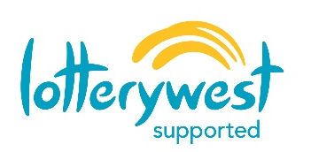
2021 Pingelly Astrofest

Stallholder Application Form

2021 Pingelly Astro Fest
Date Saturday, 20 March 2021
Venue Pingelly Recreation and Cultural Centre (Indoor Sports Hall)
Time Stallholder set up from 2pm with set up to be complete by 4pm.
Open to public 4.30pm
Stallholder dismantling 8.30pm
Site Fee Free (3m x 3m site)
Contact Sam Kempton, Community Development Officer
Email: sam.kempton@pingelly.wa.gov.au
Phone: 9887 1066
Contact Details
Name
Address

Mobile Phone
Email
Items For Sale
Please list items below to ensure suitability and assist with promotion of the event.
Public Liability
Attach a copy of the Certificate of Currency from your insurer, if applicable.
Do you have your own public liability? ☐ Yes ☐ No
Acknowledgment
I have read and understood the Terms and Conditions overleaf, and I have completed this Stallholder Application Form to the best of my knowledge.
Signature |  | Date
Terms and Conditions

- Each stall site is approximately 3m x 3m.
- Stallholders are responsible for supplying their own trestle tables and chairs.
- Food stalls are required to complete a Food Stall Permit Application with the Shire of Pingelly.
- The event organisers are not liable for any damage or loss of stock.
- Auction sales are not permitted.
- No prohibited good are too be used or sold: gas bottles, generators and other flammable equipment; firearms, alcohol, tobacco products, e-cigarettes, and/or pirated media.
- Stallholders will keep their stall site clear and repair any damage at their own expense.
- Unsold items and litter are required to be taken with the Stallholder post-event.
- Permission to conduct a raffle must be made in writing by Friday, 5 March 2020.
- Vehicle access is available from the Pingelly Recreation and Cultural Centre car park from Somerset Street.
- The event organiser reserves the right to decline any stallholder application not deemed suitable.

