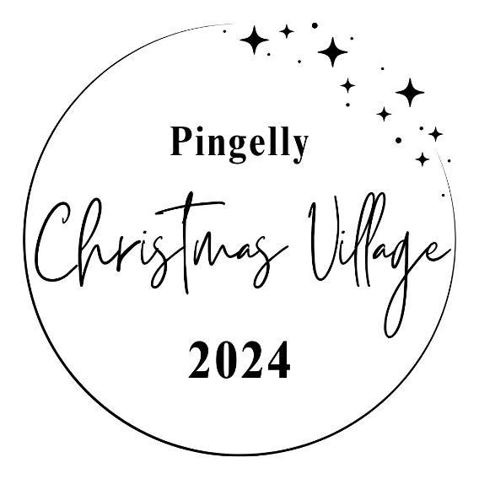**Date**: Friday 29 November 2024

**Venue**: Pasture Street Pingelly WA 6308

**Event**: 5:00pm – 9:00pm

Stall holder setup: 4:00pm

Stall holders pack-down: AFTER 9:00pm

**Return Forms to:** [admin@pingelly.wa.gov.au](mailto:admin@pingelly.wa.gov.au)

Forms must be received by 4pm – 15November 2024

**Event Coordinator:** Amy Rankin **Email:** [amy.rankin@pingelly.wa.gov.au](mailto:amy.rankin@pingelly.wa.gov.au)

**Name of Vendor**:

**Address:**

**Mobile Phone:**

**Email**:

**Products for Sale:** Please list full details as the items need to be approved.

**Do you hold current public liability insurance?** YES / NO

Certificate of currency attached: YES / NO

**Space Requirements:**

|  |  |  |  |  |  |
| --- | --- | --- | --- | --- | --- |
| Single Site 3x3 - $10 |  | Double Site 6 x 3 - $20 |  | Triple Site 9 x 3 - $30 |  |

**Site Fees:**

**To *be paid by 15 November 2024 please*.**

EFT: Shire of Pingelly, BSB: 633 000 Acc: 117984856. *Please use Vendor Name as the reference*

**Please note: Stall holders will be required to bring their own trestle tables and gazebo if they require. Christmas lights and decorations are encouraged. Sites are unpowered.**

I / We have read and agree to The Stall Holders Terms and Conditions overleaf or attached to this Booking Form.

Name:

Signed: Date:

**Stallholder Terms and Conditions**

1. **Stall Size and Equipment:**  
   Each stall site measures 3x3 metres. Additional space must be booked at the time of application. Stallholders are responsible for providing their own trestles, chairs, and gazebos.
2. **Insurance:**  
   Public liability insurance is required to hold a stall at this event and is the responsibility of each stallholder.
3. **Food Stalls:**  
   Food vendors must comply with relevant health regulations. For more information, please contact the Health Officer at the Shire of Pingelly.
4. **Liability:**  
   The Shire of Pingelly staff and event volunteers are not liable for any loss or damage, however caused, resulting from your use and occupation of a stall at the event.
5. **Auction Sales:**  
   Auction sales are prohibited at or near the stallholder's site.
6. **Site Cleanliness:**  
   Stallholders are responsible for keeping their stall clean and for repairing any damage at their own expense. Please ensure that all litter is removed, and the area is left tidy.
7. **Safety Regulations:**  
   Gas bottles, generators, or other flammable equipment are strictly prohibited within the market area.
8. **Prohibited Goods:**  
   The sale of the following items is not permitted:  
    - Illegal Items  
    - Hazardous Materials  
    - Tobacco products  
    - Age-restricted items (Alcohol stalls accepted if licensed and permitted)   
    - Offensive or inappropriate items   
    - Health and safety restricted goods  
    - Animals
9. **Waste Management:**  
   Stallholders must take away all rubbish and unsold items. A dumping fee may be charged if this is not adhered to.
10. **Raffle Permissions:**  
    If you wish to conduct a raffle, written permission must be obtained from the Event Coordinator at least a week prior to the event.
11. **Committee Rights:**  
    The Market Committee reserves the right to refuse any stall, or the sale/promotion of items deemed unsuitable.
12. **Parking:**  
    Parking will be available to all stallholders.
13. **Trading Hours:**  
    Stallholders are required to remain open to the public until 9:00pm.
14. **Shade/Weather cover:**  
    Stallholders must provide their own.

**Event Stallholder Undertaking and Indemnity:**  
By participating in the event, the stallholder agrees to indemnify the event organisers, their staff, and volunteers against any claims for damages arising from the stallholder's or the organisers' negligence, however caused. We look forward to seeing you at the Twilight Markets and celebrating the Launch of this year’s Christmas Village.